**Community Volunteering Platform**

Community Volunteering Platform is an intuitive and user-friendly platform designed to connect individuals with local volunteer opportunities, empowering them to make a meaningful impact in their communities. This platform offers a seamless experience for discovering causes, matching skills and interests, and engaging in social impact projects.

Modules to be implemented:

1. User Registration
2. Volunteer Opportunities
3. Search and Filter
4. Signup
5. Rating

Sample Screen – home page:

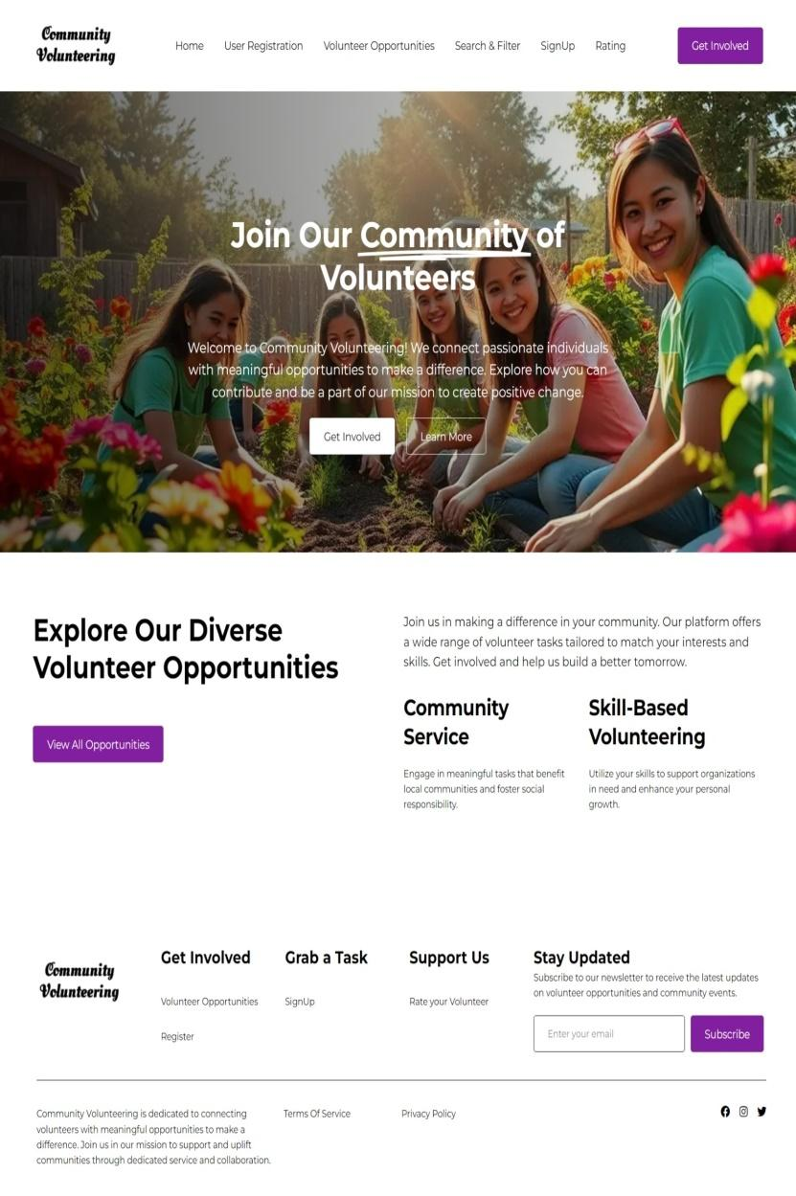

**USER REGISTRATION**

* **Registration Form:** Users (volunteers and organizations) can create an account by providing necessary details (name, email, phone, password, etc.). Users can select their role during registration as Volunteer or Organization. Upon successful registration, a verification email is sent to the user to confirm their email address. Ensure the password meets strength criteria (e.g., minimum length, combination of letters, numbers, and symbols).
* **Login/Logout:** Users can log in using email and password, and the users can log out of the platform at any time. Also, users can request a password reset via email if they forget their password.
* **Update Profile:** After successful login, Users can update their profile information (name, contact details, password, skills, etc.)
* **De-Register:** User can delete their account after email confirmation via registered email address.

Sample Screens:

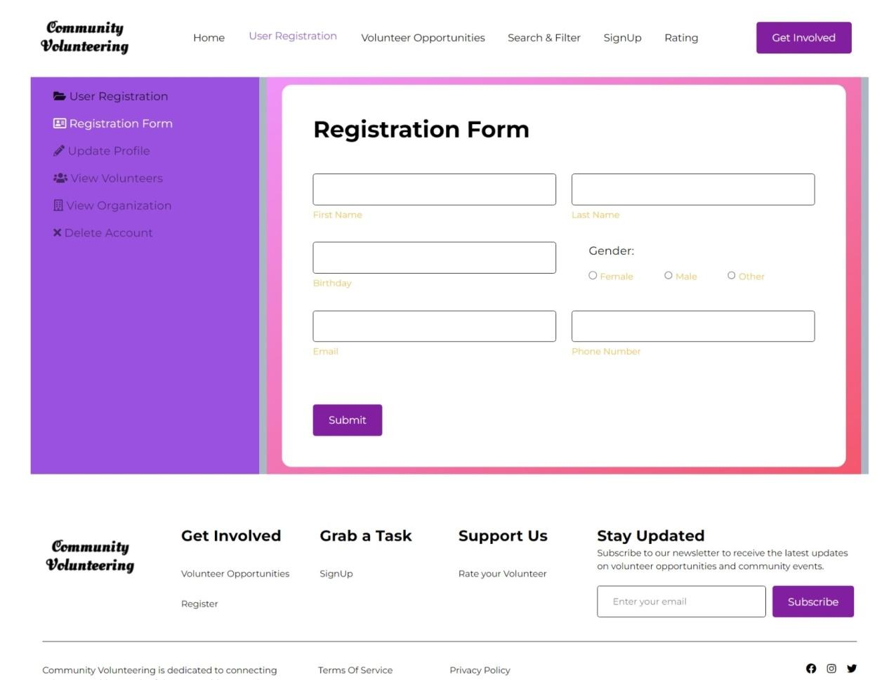

**VOLUNTEER OPPORTUNITIES**

* **Task Creation:** Organizations can create new volunteer opportunities by providing necessary details (like task title, description, location, skills, date, time, etc.)
* **Task Updating:** Organizations can edit previously created tasks to update information or change details (like task status, category, location, etc.)
* **Task Deletion:** Organizations can delete volunteer opportunities they no longer wish to offer.
* **Task Visibility:** All registered users can view volunteer tasks once they are created and published

Sample Screen:

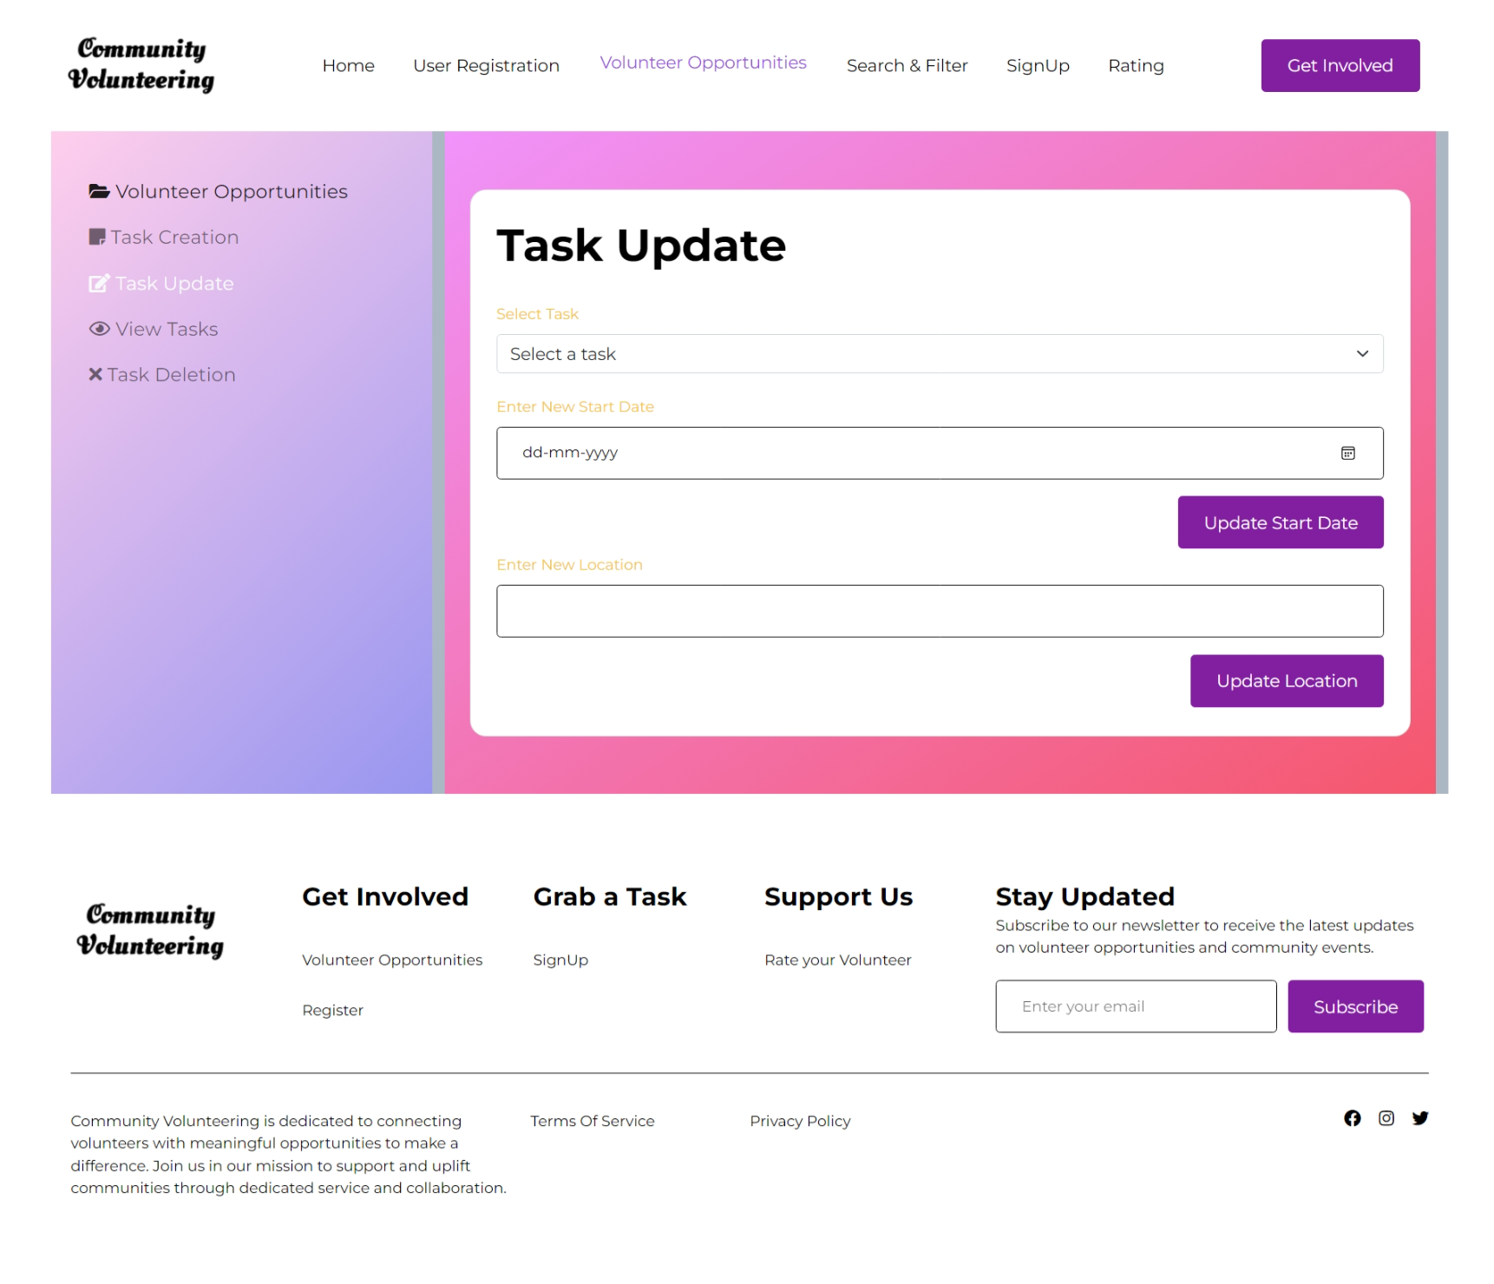

**SEARCH AND FILTER:**

* **Search Functionality:** Users can search for volunteer opportunities using keywords (e.g., task title or description).
* **Filter by Location:** Users can filter tasks by location (e.g., city, state, or zip code).
* **Filter by Skills:** Users can filter tasks by specific skills or categories (e.g., "Environmental", "Healthcare").
* **Filter by Date:** Users can filter volunteer tasks by date
* **Sort by Date/Proximity:** Users can sort the search results by task date or proximity to their location.
* **Task Details Preview:** Users can view a brief preview of each task (task title, date, location, skills required) before clicking for more details.

Sample Screen:

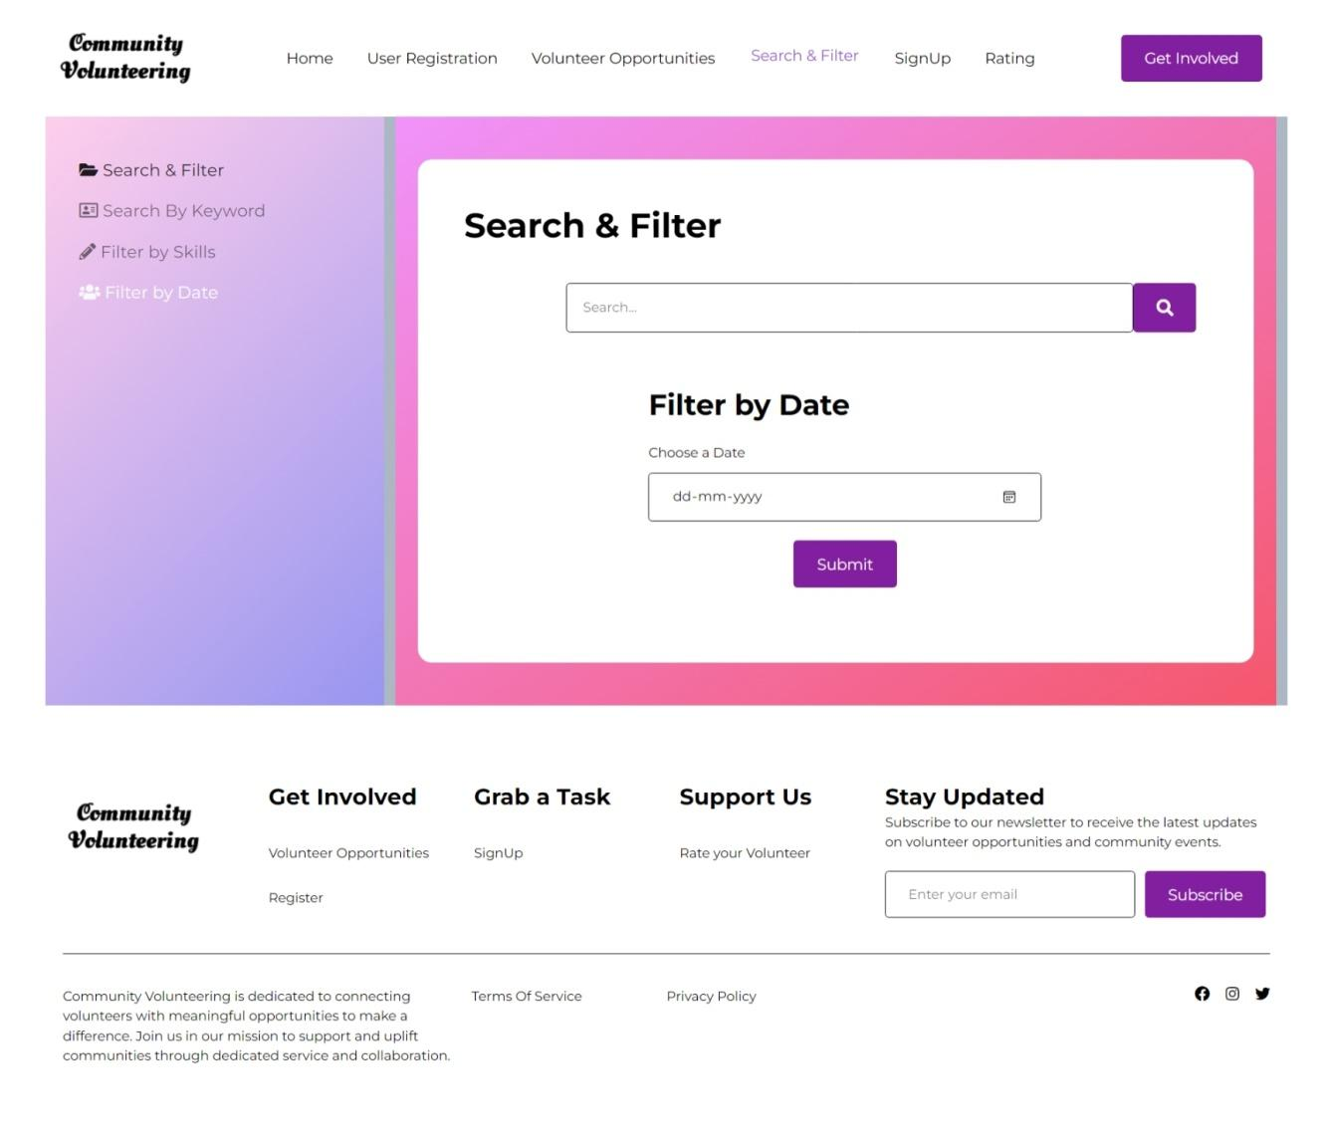

**SIGNUP:**

* **Task Signup:** Users (volunteers) can sign up for available volunteer opportunities. Once signed up, the status of those opportunities must be set as taken. Also, after signing up, users will receive a confirmation email or in-app notification with details of the task (date, time, organization, etc.)
* **Task Participation History:** Users can view a history of tasks they’ve signed up for and their status (completed, upcoming, ongoing).
* **Signup Reminder:** Users will receive reminders via email or in-app notification before the task date.
* **Signup Cancellation:** Users can cancel their signup for a task before a specified cancellation deadline.

Sample Screen:

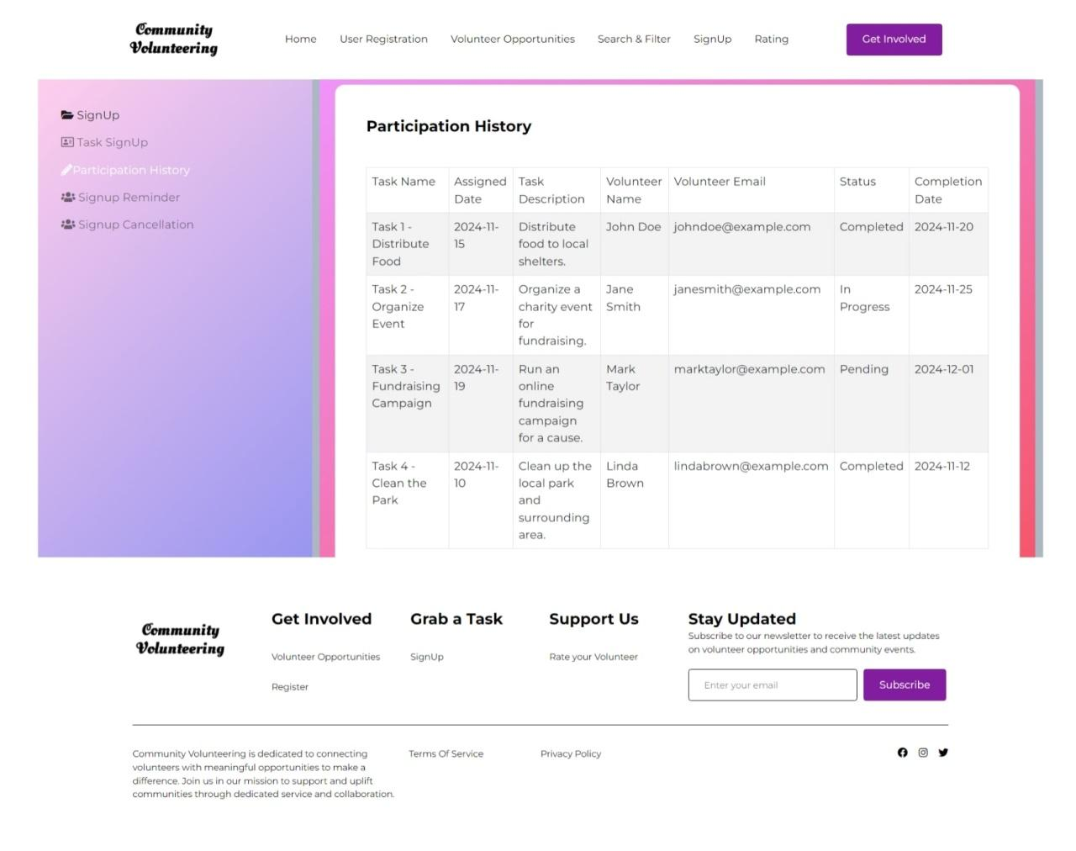

**RATING:**

* **Volunteer Rating:** Users or organizations who published a task can rate the volunteers after completion of the task
* **View Rating:** View rating of a particular volunteer or organization. Also, list of top 10 volunteers and organization can be listed based on the average rating
* **Update Rating:** Allow users to update their ratings after submitting them if they feel their opinion has changed.
* **Remove rating:** Allow users to delete their own ratings and reviews if they no longer wish to share them.

Sample Screen:

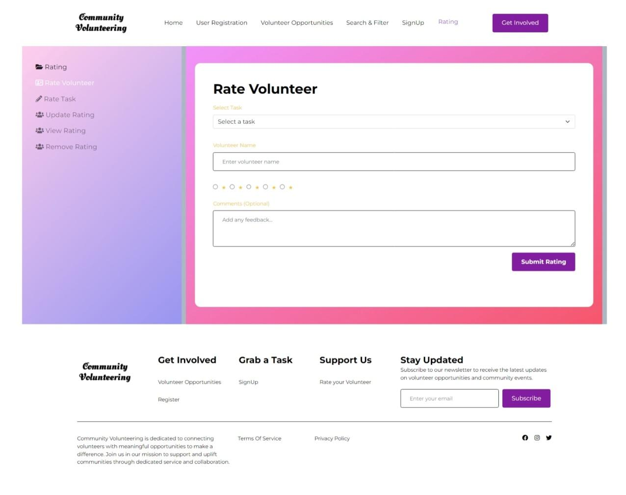

## Artifacts to be done during the project phase:

* Wire Frames
* Database Design
* Use case diagram
* Class Diagram

**Technology Stack:**

**Backend:**

* Java
* Mysql
* Spring Boot Data JPA
* Spring Boot REST Services

**Frontend:**

* Thymeleaf

**Milestone and Tasks:**

| **Milestone** | **Weeks** | **Expected Task Completion** |
| --- | --- | --- |
| 1 | Week 1 & 2 | Artifacts |
| 2 | Week 3 & 4 | Backend module implementation |
| 3 | Week 5 & 6 | Frontend module implementation |
| 4 | Week 7 & 8 | Project Integration |